1970
A 2.000 gram sample containing graphite (carbon) and an inert substance was burned in oxygen and produced a mixture of carbon dioxide and carbon monoxide in the mole ratio 2.00:1.00. The volume of oxygen used was 747.0 milliliters at 1,092K and 12.00 atmospheres pressure. Calculate the percentage by weight of graphite in the original mixture.
Answer:
C + ⁵/₂ O₂ → 2 CO₂ + CO
OR 2 C + 5 O₂ → 4 CO₂ + 2 CO
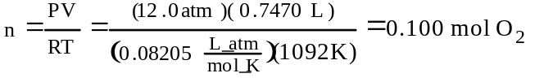
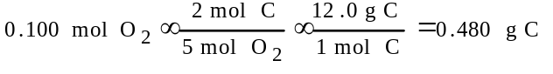
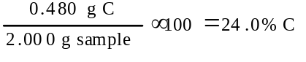

1982 B
Water is added to 4.267 grams of UF₆. The only products are 3.730 grams of a solid containing only uranium, oxygen and fluorine and 0.970 gram of a gas. The gas is 95.0% fluorine, and the remainder is hydrogen.
(a) From these data, determine the empirical formula of the gas.
(b) What fraction of the fluorine of the original compound is in the solid and what fraction in the gas after the reaction?
(c) What is the formula of the solid product?
(d) Write a balanced equation for the reaction between UF₆ and H₂O. Assume that the empirical formula of the gas is the true formula.
Answer:
(a) Assume 100 g of compound
(95.0 g F)(1 mol F/19.0g) = 5.0 mol F
(5.0 g H)(1 mol H/1.00g) = 5.0 mol H
5.0 mol F : 5.0 mol H = 1 F : 1 H, = HF
(b) 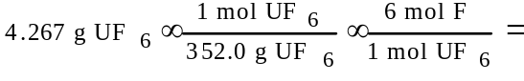
= 0.07273 mol F in original compound
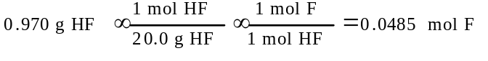
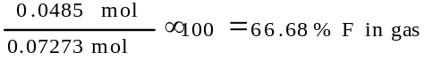
(100.0 - 66.68)% = 33.32% F in solid
(c) 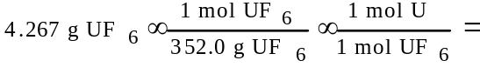
= 0.01212 mol U
(0.07273 mol F in original compound) - (0.0485 mol F in gas) = 0.02433 mol F in solid
(4.267 + X)g = (3.730 + 0.970)g; X = 0.433 g H₂O
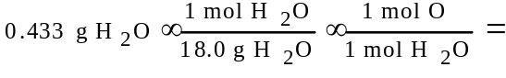
= 0.02406 mol O
0.01212 mol U/0.01212 mol = 1
0.02433 mol F/0.01212 mol = 2.007
0.02406 mol O/0.01212 mol = 1.985
= UF₂O₂
(d) UF₆ + 2 H₂O → UF₂O₂ + 4 HF

1986 B
Three volatile compounds X, Y, and Z each contain element Q. The percent by weight of element Q in each compound was determined. Some of the data obtained are given below.
Percent by weight Molecular
Compound of Element Q Weight
X 64.8% ?
Y 73.0% 104.
Z 59.3% 64.0
(a) The vapor density of compound X at 27°C and 750. mm Hg was determined to be 3.53 grams per litre. Calculate the molecular weight of compound X.
(b) Determine the mass of element Q contained in 1.00 mole of each of the three compounds.
(c) Calculate the most probable value of the atomic weight of element Q.
(d) Compound Z contains carbon, hydrogen, and element Q. When 1.00 gram of compound Z is oxidized and all of the carbon and hydrogen are converted to oxides, 1.37 grams of CO₂ and 0.281 gram of water are produced. Determine the most probable molecular formula of compound Z.
Answer:
(a) 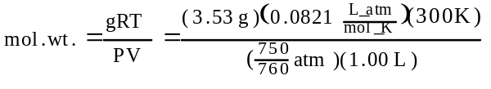
= 88.1 g/mol
(b) X Y Z
88.1 g/mol 104 64.0
% Q 64.8 73.0 59.3
g Q 57.1 75.9 38.0
(c) ratio 1.5 2 1
masses must be integral multiples of atomic weight
therefore, 3 4 2
which gives an atomic weight of Q = 19
(d)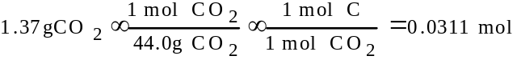
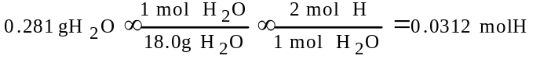
1.00 g Z is 59.3% Q = 0.593 g Q
0.0593 g Q × f(1 mol,19.0 g) = 0.0312 mol Q
therefore, the empirical formula = CHQ, the smallest whole number ratio of moles.
formula wt. of CHQ = 32.0, if mol. wt. Z = 64 then the formula of Z = (CHQ)₂ or C₂H₂Q₂

1991 B
The molecular formula of a hydrocarbon is to be determined by analyzing its combustion products and investigating its colligative properties.
(a) The hydrocarbon burns completely, producing 7.2 grams of water and 7.2 liters of CO₂ at standard conditions. What is the empirical formula of the hydrocarbon?
(b) Calculate the mass in grams of O₂ required for the complete combustion of the sample of the hydrocarbon described in (a).
(c) The hydrocarbon dissolves readily in CHCl₃. The freezing point of a solution prepared by mixing 100. grams of CHCl₃ and 0.600 gram of the hydrocarbon is -64.0°C. The molal freezing-point depression constant of CHCl₃ is 4.68°C/molal and its normal freezing point is -63.5°C. Calculate the molecular weight of the hydrocarbon.
(d) What is the molecular formula of the hydrocarbon?
Answer:
(a)
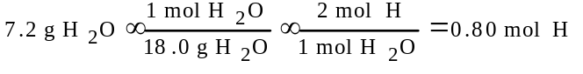
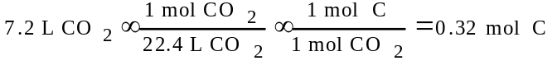
(or PV=nRT could be used to solve for n)
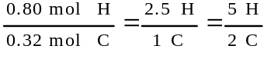
??C₂H₅
(b) 0.40 mol oxygen in water + 0.64 mol oxygen in CO₂ = 1.04 mol O = 0.52 mol O₂ = 16.64 g = 17 g of oxygen gas (alternative approach for mol O₂ from balanced equation)
(c) û63.5°C û (û64.0°C) = 0.5°C
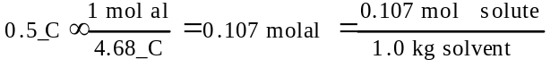
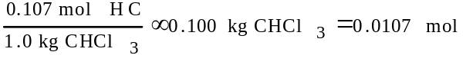
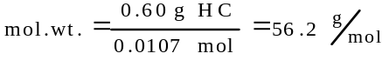
OR
solve for mol. wt. using
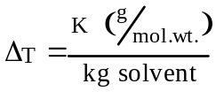
(d) C₂H₅ = 29 g mol⁻¹
56.2/29 = 1.93 = 2, ? (C₂H₅)₂ = C₄H₁₀

1993 B
I. 2 Mn²⁺ + 4 OH⁻ + O₂(g) → 2 MnO₂(s) + 2 H₂O
II. MnO₂(s) + 2 I⁻ + 4 H⁺ → Mn²⁺ + I₂(aq) + 2 H₂O
III. 2 S₂O₃²⁻ + I₂(aq) → S₄O₆²⁻ + 2 I⁻
The amount of oxygen, O₂, dissolved in water can be determined by titration. First, MnSO₄ and NaOH are added to a sample of water to convert all of the dissolved O₂ to MnO₂, as shown in equation I above. Then H₂SO₄ and KI are added and the reaction represented by equation II proceeds. Finally, the I₂ that is formed is titrated with standard sodium thiosulfate, Na₂S₂O₃, according to equation III.
(a) According to the equation above, how many moles of S₂O₃²⁻ are required for analyzing 1.00 mole of O₂ dissolved in water?
(b) A student found that a 50.0-milliliter sample of water required 4.86 milliliters of 0.0112-molar Na₂S₂O₃ to reach the equivalence point. Calculate the number of moles of O₂ dissolved in this sample.
(c) How would the results in (b) be affected if some I₂ were lost before the S₂O₃²⁻ was added? Explain.
(d) What volume of dry O₂ measured at 25°C and 1.00 atmosphere of pressure would have to be dissolved in 1.00 liter of pure water in order to prepare a solution of the same concentration as that obtained in (b)?
(e) Name an appropriate indicator for the reaction shown in equation III and describe the change you would observe at the end point of the titration.
Answer:
(a) 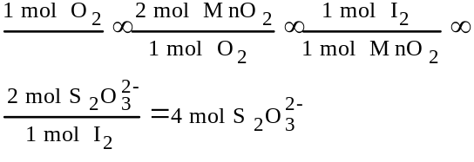
(b) mol S₂O₃²⁻ = (0.00486 L)(0.0112 M) = 5.44?10⁻⁵ mol S₂O₃²⁻
1.36?10⁻⁵ mol O₂
(c) less I₂ means less thiosulfate ion required thus indicating a lower amount of dissolved oxygen.
(d) molarity of solution in (b) = 1.36?10⁻⁵ mol O₂ / 0.050 L = 2.72?10⁻⁴ M

= 6.65?10⁻⁵ L or 6.65 mL O₂
(e) starch indicator
color disappears or blue disappears
[color _ alone is not sufficient for 2nd pt.; any other color w/starch is not sufficient for 2nd pt.]

1995 B
A sample of dolomitic limestone containing only CaCO₃ and MgCO₃ was analyzed.
(a) When a 0.2800 gram sample of this limestone was decomposed by heating, 75.0 milliliters of CO₂ at 750 mm Hg and 20°C were evolved. How many grams of CO₂ were produced.
(b) Write equations for the decomposition of both carbonates described above.
(c) It was also determined that the initial sample contained 0.0448 gram of calcium. What percent of the limestone by mass was CaCO₃?
(d) How many grams of the magnesium-containing product were present in the sample in (a) after it had been heated?
Answer:
(a) 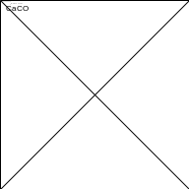
= 3.08?10^{û3} mol
3.08?10^{û3} mol ? f(44.0 g CO₂,1 mol) = 0.135 g CO₂
(b) CaCO₃ → CaO + CO₂
MgCO₃ → MgO + CO₂
(c) 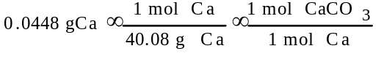
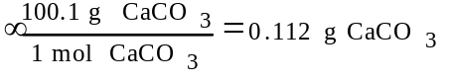
f(0.112 g CaCO₃,0.2800 g sample) = 40.0% CaCO₃
(d) 60.0% of 0.2800 g sample = 0.168 g of MgCO₃
